OCEANA COUNTY JUNIOR MARKET
EDUCATIONAL RECORD BOOK

Young Beef/Dairy & Feeder Calf Project - 2026
(for ages 5-7)


If you are a little buddy check here: _____

My big buddy is: _________________________________________

As a member of the Junior Market Animal Project, you are required to submit your records as part of an educational project notebook in order to show your animal at the Oceana County Fair. This notebook must be shown to the Oceana County 4-H Market Livestock Committee's Weighmaster at the time of weigh-in and then entered by you in the Educational Notebook Division of the Oceana County Fair on Entry day.

AGE: _____

Number of years in project: _____

Remember: The age you enter depends on how old you are or will be on January 1, 2026.

Use this sheet as the first page of your project record book. Fill it out completely.
Please print or type neatly.

NAME______________________________________________________________________________

4-H CLUB___________________________________________________________________________

BREED______________________________________ NAME_____________________________

ANIMAL DATE OF BIRTH____________________ DATE RECORD STARTED___________________

LOCATION OF WHERE ANIMAL IS RAISED _____________________________________________

JUDGE’S SCORE/COMMENT SHEET

(PLEASE DO NOT REMOVE, PLACE THIS SHEET IN SHEET PROTECTOR OR GLUE TO COVER). This sheet must be kept free to the judge to write their comments.

This sheet should help each junior market member understand their ribbon placing.

A. Specific educational value or worth

___ All questions were answered completely

___ All calculations were correct

___ Calculations were incorrect

___ Questions were not completely answered

___ Questions were not answered (missed questions)

B. Notebook contains all project records

___ Notebook contained all project records and were fully completed

___ Notebook contained additional project related information (research

materials etc.)

___ Project records were incomplete

___There was no additional project related information

C. Accuracy, neatness and general appearance

___Notebook was neat in appearance (typed/hand printed)

___ Notebook pages were clean and stain free

___Notebook pages were in order and complete

___Notebook pages were out of order and missing pages

___Notebook was difficult to read and messy

___Notebook had wrinkled and stained pages

Other Comments: __________________________________________________________________________

____________________________________________________________________________________________

____________________________________________________________________________________________

2024- Jr. Mkt Feeder/Young Beef Page 2

OBJECTIVES

- Develop desirable work habits, sportsmanship, and ability to cooperate and express ideas through participation in projects, discussions, method demonstrations, judging teams, and exhibits.
- Experience the pride and responsibility of leasing/owning and caring for beef.
- Learn how to feed, fit, show, breed and raise beef.
- Learn proper handling procedures to prevent injuries to members and their beef projects.
- Appreciate and use scientific information in beef production and marketing.
- Improve knowledge of grading, marketing and merchandising of beef products.
- Learn the importance of the beef industry to the local, state, and national economies.
- Acquire information on the opportunity that beef offers as a career.
This record book is part of your Junior Market Young Beef/Feeder Calf project. By keeping records up-to-date you will be able to see how much progress you make as you set goals and work to accomplish them. Write or type neatly and clearly. Please keep the pages in order. Feel free to add extra pages at the end of your notebook. Pictures are a required part of your notebook. Taking pictures of your project animal throughout the project will indicate how your animal has grown and developed. Add pictures to your notebook on a separate piece of paper.

SCORING CRITERIA

The following breakdown will be used during the judging process of all market livestock notebooks.

A. Specific educational value or worth 30%
B. Creative way of showing what has been learned 10%
C. Notebook contains all project records 50%

D. Accuracy, neatness and general appearance 10%

The Oceana County Agricultural Society encourages parent assistance with your project and project notebook.

If you needed extra help in filling out your notebook please have whoever helped sign below that the answers are YOUR answers and that they assisted you in the writing of the answers and understanding of the questions only. The judges prefer to see the youth’s handwriting over the adults in most cases.

(signature of person helping with writing if needed)

2026- Jr. Mkt Feeder/Young Beef Page 3

ABOUT YOUR CALF

My Calf’s name is: _______________________________________________________________

My Calf’s breed is: _______________________________________________________________

What color is your Calf? __________________________________________________________

My Calf’s favorite things to do is: _________________________________________________

__________________________________________________________________________________

COLOR THE PICTURE- COLOR THE CALF TO LOOK LIKE YOURS

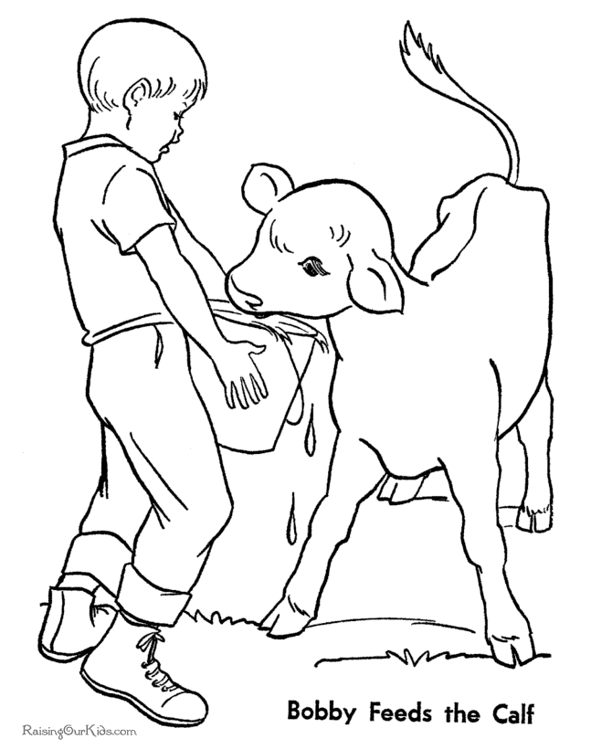

2026- Jr. Mkt Feeder/Young Beef Page 4

JOURNAL OF ANIMAL CARE

The 4-H SMAA Committee is requiring all members to complete the “Journal of Care” so the judge may see the time, effort and care you have put into learning about your animal. What did you do to keep your animal healthy and prepare them for fair?

** Include things such as walked, fed, washed, clipped, trimmed, foot care, health practices, medicines, general maintenance (cleaning living & feed area), halter broke, training, had vaccinated, etc. **please attach additional sheet for more room.

_____________________________________________________________________________

_____________________________________________________________________________

_____________________________________________________________________________

______________________________________________________________________________

______________________________________________________________________________

______________________________________________________________________________

______________________________________________________________________________

______________________________________________________________________________

______________________________________________________________________________

______________________________________________________________________________

______________________________________________________________________________

______________________________________________________________________________

______________________________________________________________________________

______________________________________________________________________________

______________________________________________________________________________

______________________________________________________________________________

______________________________________________________________________________

______________________________________________________________________________

_______________________________________________________________________

2026- Jr. Mkt Feeder/Young Beef Page 5

PROJECT INFORMATION

The start of the project will be the date the exhibitor placed the animal on feed. The end of the project will be weigh-in at fair.

Project Start Date: ___________________ Project End Date: ___________________

What month was your calf born? _____________________________________

Please fill in the following information about your calf.

Calf’s Name | Calf’s RFID Number | Breed | Date of Purchase | Price or Value | Estimated Starting Weight | Ending Weight | Total Pounds Gained
Note: Ending Weight-Starting Weight= Total Pounds Gained

I,______________________________, do attest and certify that this 4-Her has cared for
(property owner name-please print-if parent put parent’s name)

animal in a responsible manner while housed on my property. I also understand that integrity & responsibility are important to this 4-H experience.

____________________________________ ________ _________________
Signature of Property Owner or Parent Date
If housed on own property.

2026- Jr. Mkt Feeder/Young Beef PAGE 6

(A.) MONTHLY FEED RECORD & EXPENSES
(have a parent, grandparent, older 4-H member, leader, etc. help you with this)

Month | Type of feed used | Lbs. of feed used for the month | Cost of feed used for the month
February
March
April
May
June
July
August

(A) Total Cost of Feed $__________________________
2026- Jr. Mkt Feeder/Young Beef PAGE 7

(B) OTHER PROJECT EXPENSES

DATE | VET, BEDDING, EQUIPMENT, TRUCKING, CLIPPING, MARKETING/BUYER RECOGNITION, ETC. | COST
 |  | $
 | (B) TOTAL SPENT ON OTHER EXPENSES | $

(C) COST OF FEEDER CALF $_____________

TOTAL EXPENSES (A+B+C) = $ __________ (TE)

_______________ ÷ _________________ = ___________________________________________
Total Expenses (TE) Final Weight (FW) Break Even Price (BE)
(or total cost per pound to raise your animal)

** Have your parent, leader or an older teen in your club help you figure out your breakeven price. The breakeven price is the price that you need to get at the Junior Market animal auction in order to not lose money on your market project. **
2026- Jr. Mkt Feeder/Young Beef Page 8

ANSWER THE FOLLOWING QUESTIONS:
(the judge wants the answer in YOUR words, even if someone helped with the printing)

ANSWER THE FOLLOWING QUESTIONS:

1. Why did you pick the calf that you picked? ______________________________________________

____________________________________________________________________________________

____________________________________________________________________________________

____________________________________________________________________________________

2. What is the best feature(s) of your market calf?______________________________________

____________________________________________________________________________________

____________________________________________________________________________________

____________________________________________________________________________________

3. What feature(s) of your market calf could use improvement? _____________________

____________________________________________________________________________________

____________________________________________________________________________________

____________________________________________________________________________________

POTENTIAL BUYERS NAMES

As part of your Jr. Market Livestock Project, you must personally contact at least five potential buyers before the Oceana County Fair. You are encouraged to seek two new buyers that have not been asked or submitted before. You also must have at least three different buyers than those of your siblings in the market livestock project. Please confirm with your buyers their accurate mailing address (example: post office box vs. a street address). The information on page 9 must be completed and taken to the Oceana County MSU Extension Office on or before the due date where it will be copied and used to send out letters to your potential buyers. This page will remain in your notebooks. This is a Market Livestock Committee rule. Failure to comply will result in you not being able to sell your animal in the Jr. Market Livestock Sale.

2026- Jr. Mkt Feeder/Young Beef Staff ____________
Page 9 Date ____________

JUNIOR MARKET POTENTIAL BUYER’S LIST
FEEDER CALF PROJECT (AGES 5-7)

Name______________________________ Club_________________________
Please print business names and complete addresses clearly.

  - Contact Name ___________________________________________________________

Business Name __________________________________________________________

Mailing Address ___________________________City________________Zip_________

Phone _______________________ After Hours Phone______________________
Mailing Preference (Please Check One): Email ____ Postal Delivery ____

Email ___________________________________________________________________

Signature________________________________________________________________

2. Contact Name ___________________________________________________________

Business Name __________________________________________________________

Mailing Address ________________________City ____________________Zip_________

Phone _______________________ After Hours Phone______________________
Mailing Preference (Please Check One): Email ____ Postal Delivery ____

Email __________________________________________________________________

Signature_______________________________________________________________

3. Contact Name _________________________________________________________

Business Name _________________________________________________________

Mailing Address________________________ City _________________ Zip_____

Phone _______________________ After Hours Phone______________________
Mailing Preference (Please Check One): Email____ Postal Delivery ____

Email _________________________________________________________________

Signature______________________________________________________________

(Must be stamped by the MSU Extension Office)
2026- Jr. Mkt Young Beef and Feeder Calf Page 10

PICTURES OF YOUR PROJECT

(Please use this page for your project pictures. Add additional pages if you would like. The judges appreciate you labeling the pictures so they know what the picture shows.)

NON-CLUB POINTS

JUNIOR MARKET/SMALL MARKET ANIMAL ASSOCATION PROJECT
ATTENDANCE RECORD
(this must be filled out when presenting for signatures at the office

MEETING NAME | LOCATION | DATE | POINTS | SIGNATURE OF LEADER, SUPERINTENDENT OR MSU STAFF
Please note: This form must be included with your record notebook and turned into the weigh master on entry day of the Fair. BEFORE SEEKING SIGNATURES AT MSU EXTENSION – MEETING NAME AND DATE MUST BE COMPLETED. You need to accumulate nine (9) points to be allowed to sell your animal. Six (6) of these nine (9) points must come from club meetings. Two (2) of these 9 points are non-club points must be earned from attending various 4-H events and activities. One (1) of these 9 points must be a fairgrounds workbee point. No more than 2 non-club points can be earned from fairground workbees. See your leader, the MSUE office, or online at https://www.canr.msu.edu/oceana/oceana_county_4_h/oceana_4_h_market_livestock for a listing of approved nonclub points.
JUNIOR MARKET/SMALL MARKET ANIMAL ASSOCATION PROJECT
ATTENDANCE RECORD
(this must be filled out when presenting for signatures at the office)
MEETING NAME | LOCATION | DATE | POINTS | SIGNATURE OF LEADER, SUPERINTENDENT OR MSU STAFF
Please note: This form must be included with your record notebook and turned into the weigh master on entry day of the Fair. BEFORE SEEKING SIGNATURES AT MSU EXTENSION – MEETING NAME AND DATE MUST BE COMPLETED. You need to accumulate nine (9) points to be allowed to sell your animal. Six (6) of these nine (9) points must come from club meetings. Two (2) of the 9 points are non-club points and must be earned from attending various 4-H events and activities. One (1) of the 9 points must be a fairgrounds workbee point. No more than 2 non-club points can be earned from fairground workbees.

